Introduction:

Topic : Fuel prices in Texas and correlation with the demands for the year 2010 to 2018.

The topic is based on current problems faced by the people around the world with the increase in the population each year.

The data for past 8 years was collected for fuel prices and fuel consumption month wise from the website [www.rrc.state.tx.us](http://www.rrc.state.tx.us/).

Fuel consumption and its availability is a major issue now a days, with the rise in the demand the price of the fuel is being fluctuated. In this project analysis of the fuel demand and its prices over the months and years is done to find a correlation between them.

The data which was obtained was as follows.

fuel prices over the years monthly:

Fuel prices over the years:

Year Jan Feb Mar Apr May Jun Jul Aug Sep Oct Nov Dec

  2010 2.622 2.549 2.693 2.788 2.796 2.657 2.628 2.636 2.594 2.699 2.726 2.885   2011 2.995 3.105 3.486 3.746 3.839 3.601 3.597 3.586 3.474 3.323 3.253 3.14   2012 3.267 3.526 3.759 3.844 3.595 3.369 3.324 3.581 3.709 3.541 3.246 3.147   2013 3.238 3.55 3.624 3.473 3.452 3.461 3.518 3.509 3.383 3.18 3.104 3.171   2014 3.187 3.213 3.373 3.541 3.522 3.55 3.513 3.366 3.281 3.056 2.781 2.392

  2015 1.976 2.089 2.303 2.326 2.529 2.641 2.604 2.424 2.158 2.101 1.993 1.89   2016 1.793 1.648 1.855 1.986 2.122 2.229 2.144 2.073 2.07 2.125 2.051 2.122   2017 2.234 2.171 2.187 2.313 2.281 2.244 2.168 2.263 2.609 2.399 2.375 2.302   2018 2.391 2.402 2.43 2.598

fuel consumption over the years:

Texas Natural Gas Vehicle Fuel Consumption

Year Jan Feb Mar Apr May Jun Jul Aug Sep Oct Nov Dec

  2010 198 179 198 192 198 192 198 198 192 198 192 198   2011 187 169 187 181 187 181 187 187 181 187 181 187   2012 187 175 187 181 187 181 187 187 181 187 181 187   2013 255 230 255 247 255 247 255 255 247 255 247 255   2014 353 319 353 342 353 342 353 353 342 353 342 353

  2015 373 337 373 361 373 361 373 373 361 373 361 373   2016 378 354 378 366 378 366 413 413 399 413 399 413   2017 434 392 434 420 434 397 412 412 398 412 398 412   2018 411 371 411 397

The consumption of fuel and prices per gallon in texas is initially plotted to get the idea of how the data looks like:

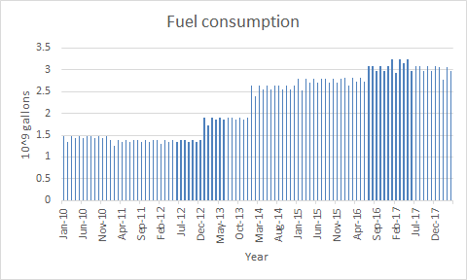

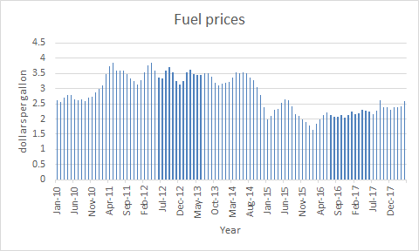

The data so obtained was analyzed and results were as obtained:

For analysis linear regression was utilized and equations were obtained from which the future demand was predicted.

fuel consumption equation : y = 0.0007x - 28.741

fuel price equation : y = -0.0004x + 20.416

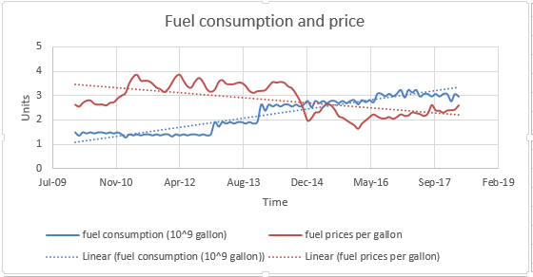

forecast data:

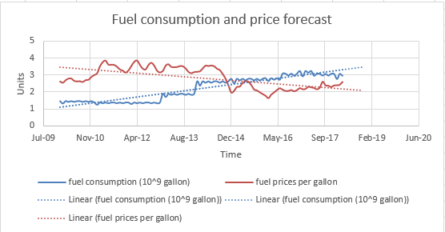

Results: From the graph we can see that in future the prices are going to drop and hence the demand in Texas is going to increase.

The price is going to be around $ 2.216 per gallon and consumption is increasing to 3.109 * 10^9 gallons.